Multiple choice section

Question 1 [9.2]

What is the median of the following numbers?  
 4 4 6 5 8

A 4 B 5 C 5.4 D 6

Question 2 [9.3]

The following column graph shows the favourite football team for Year 7 students.

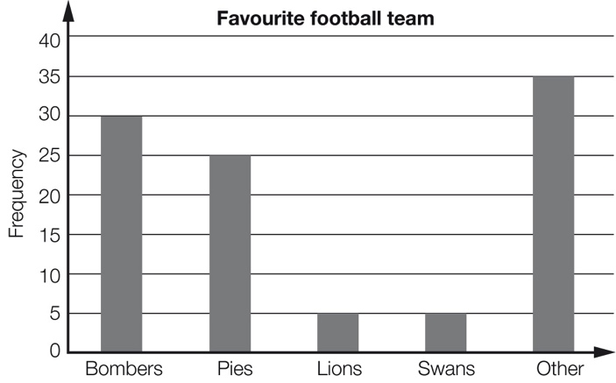

The approximate percentage of students who support the Pies or the Lions is:

A 5 B 20 C 25 D 30

Question 3 [9.7]

A normal die is rolled once. The probability of rolling a multiple of 3 is:

A  B  C  D 2

Question 4 [9.4]

The best type of statistical graph to display the brand of car owned by a selection of 100 car owners is a:

A sector graph B line graph C histogram D stem-and-leaf plot

Question 5 [9.2]

What is the mean of the following data?   
 2 2 3 5 8 10 12

A 2 B 5 C 6 D 7

Question 6 [9.1]

The following data list records the street address numbers for each of the students in a class.

28 44 59 3 148 90 82 16 43 33 21 18 21 45 36 20 45 77 111 40 2 15 18 19 25

The frequency for the 11−20 group is:

A 4 B 5 C 6 D 7

Question 7 [9.7]

When Victor and Brenda played Scrabble in the past, Victor won 6 games and Brenda won 5.  
The probability that Victor will win the next game is:

A 54% B 46% C 45% D 55%

Question 8 [9.4]

In one class, 46% of students have brown hair. If a sector graph is to be drawn showing hair colour, then the number of degrees required for brown hair is:

A 46° B 54° C 82.8° D 166°

Question 9 [9.5]

Rhonda has a 5000 L water tank that she uses to water her vegetable garden. The graph shows the amount of water in the tank at the beginning of the week for a 12-week period.

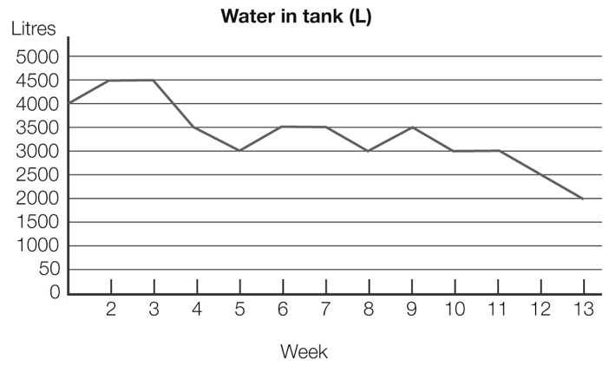

In which weeks can you be certain there was rain?

A 5, 10 and 11 B 4, 7 and 8

C 3, 6 and 7 D 1, 5 and 8

Question 10 [9.4]

The graph below shows the percentage contribution of various activities to Australia’s greenhouse gas emission.

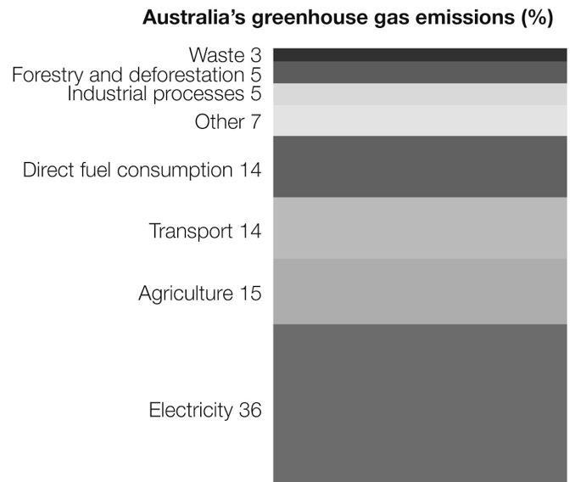

Agriculture and transport together contribute:

A 14% B 15% C 29% D 36%

Question 11 [9.2]

What is the mode of the following numbers?

1, 3, 5, 3, 4, 2, 3, 1, 4, 2

A 1, 2 and 4 B 3 C 10 D 28

Question 12 [9.3]

A school has students from Year 1 to Year 9. The following histogram shows their height.  
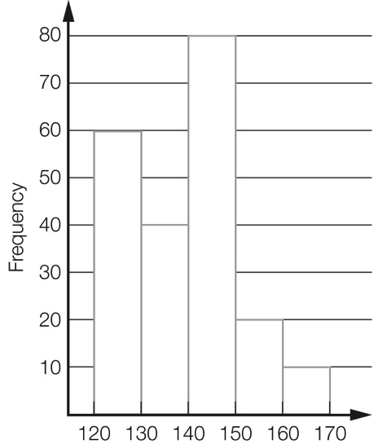  
 Height (cm)

The number of students with a height less than 150 cm is:

A 30 B 80 C 180 D 210

Multiple-choice total marks: ____ / 12

Short answer section

Question 13 3 marks [9.2, 9.6, 9.7]

Use words from the list below to complete the following sentences.

bivariate data categorical data mean median probability sample space

(a) The ______________ of a data set is found by adding together all the results and dividing by the number of results.

(b) The ________________________ of an event is found by dividing the number of successful outcomes by the total number of outcomes.

(c) If we record the colour of cars in a car park we are dealing with _______________________ .

Question 14 2 marks [9.6]

Explain the difference between continuous numerical data and discrete numerical data. Give an example of each to help you explain the difference.

Question 15 10 marks [9.3]

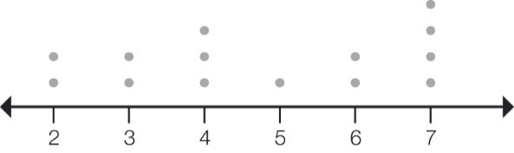

(a) For the dot plot above, find the:

(i) mean (correct to 1 decimal place) (ii) median

(iii) mode (iv) range

(b) If one of the 7s is replaced by the outlier 12, what effect does this have on the answers for (a)?

(i) mean (ii) median

(iii) mode (iv) range

Question 16 4 marks [9.5]

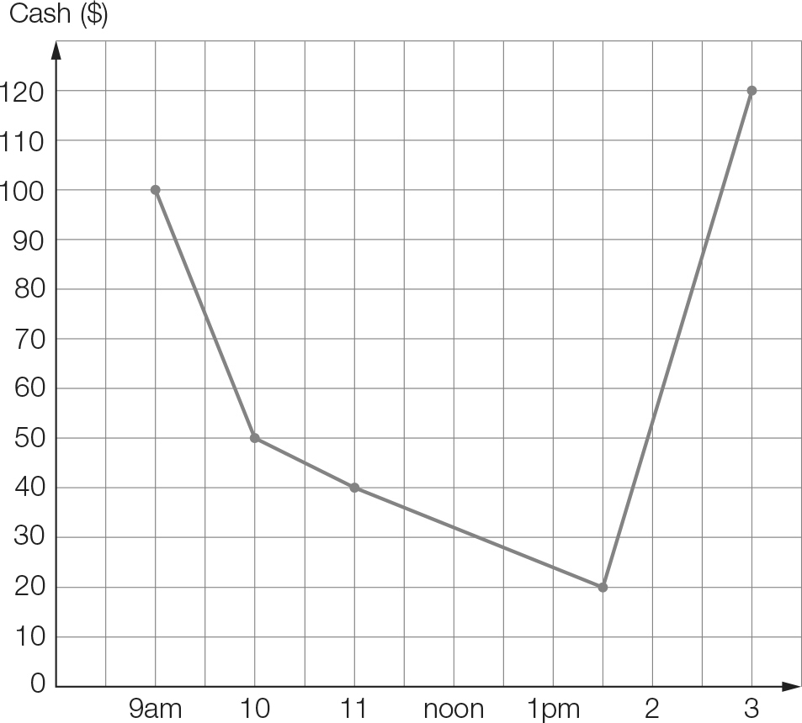

Joanie went to the shopping mall at 9 am with $100 in her wallet. She recorded the amount of money in her wallet following each transaction.

(a) What was the largest amount that Joanie spent and when was this?

(b) At what time did Joanie go to the cash point? How much did she withdraw?

(c) For what period of time did Joanie have $40 in her wallet?

(d) For what period of time did Joanie have less than $80 in her wallet?

Question 17 6 marks [9.3]

A class of year 7 students kept a tally of the number of movies they saw throughout the term. Here are their results.

25 37 15 12 5 40 31 43 22 14 27 38

19 26 8 25 19 11 10 20 44 9 6 26

(a) Construct an ordered stem-and-leaf plot to show the data using stems of 0, 1, 2 etc.

|  |  |
| --- | --- |
| STEM | LEAF |
|  |  |
|  |  |
|  |  |
|  |  |
|  |  |

(b) Describe the distribution of data using median and range.

(c) Expand the graph by showing the upper and lower parts of each stem separately, i.e. 0–4 with the lower stem and 5–9 with the upper stem. Use 0U, 1L, 1U etc. as the leaves.

|  |  |
| --- | --- |
| STEM | LEAF |
|  |  |
|  |  |
|  |  |
|  |  |
|  |  |
|  |  |

(d) Describe what this distribution shows (if anything) that was not clear previously.

Question 18 7 marks [9.4]

A report on speeding fines in Victoria showed that of the average of about 3500 fines every day, 2530 were for drivers going less than 10 km/h over the limit, 962 for going more than 10 but less than 20 km/h over the limit, and 8 for going 20 km/h or more over the limit.

(a) If you were to draw a pie graph of these categories, what angle would represent drivers fined for going less than 10 km/h over the limit?

(b) If a divided bar chart was used, what would you make the total length, and what length would represent drivers of between 10 and 20 km/h over the limit?

(c) The highest category can be further broken down to 2 between 20 and 45 km/h over the limit and 6 more than 45 km/h over the limit.

(i) What would be the angles and lengths on your graphs for each category?

(ii) Explain how you might make these amounts clear for someone reading your graph.

Question 19 5 marks [9.6]

The average monthly maximum temperatures are given for two cities in Australia.

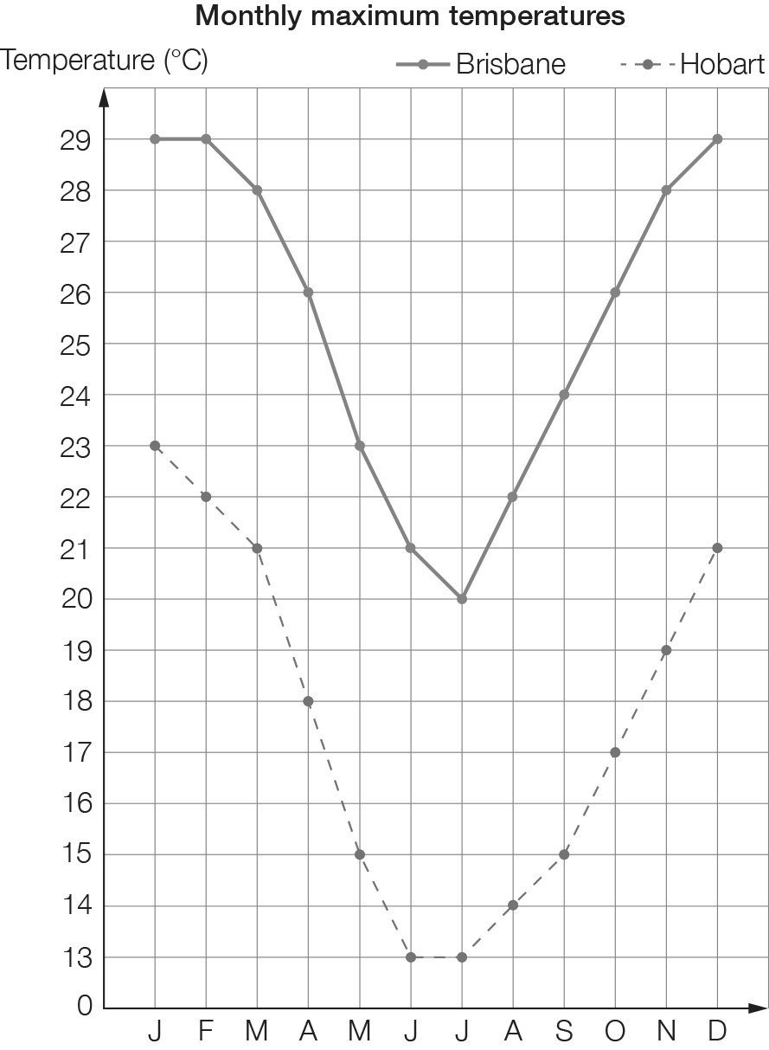

Compare the temperatures of the two cities from the graph and from calculations of the median and range for each city.

Question 20 7 marks [9.7]

A large spinning wheel is constructed and is divided into 20 equally sized sectors numbered from 1 to 20. The wheel is spun once. Find the probability of each of the following events.

(a) The spinner lands on 15.

(b) The spinner lands on a multiple of 5.

(c) The spinner lands on a multiple of 9.

(d) The spinner lands on a prime number.

(e) The spinner lands on a multiple of 3 or a multiple of 6.

Question 21 5 marks [9.7]

A card is drawn from a standard pack of 52 playing cards.

(a) How many outcomes are there in the sample space?

(b) Find the following probabilities:

(i) Pr(King)

(ii) Pr(King or Queen)

(iii) Pr(King or red card)

Short answer total:_________/49

Extended answer section

Question 22 7 marks [9.1, 9.3, 9.4]

The Year 7 class has been training for the Athletic Sports. Each student ran 100 m and had their time recorded. This was written in seconds to the nearest tenth of a second. The times were:

12.6 13.1 11.9 13.0 12.6 12.7 13.1 14.0 13.8 12.5 12.6 12.7 13.6

14.3 14.4 14.0 12.9 13.0 14.2 13.7 13.3 12.7 13.5 11.9 14.0

(a) Is this data discrete or continuous?

(b) Construct a frequency table using class intervals of 11.5−<12.0, 12.0−<12.5, etc.

(c) Construct a frequency column graph to show the data.

(d) What percentage of students ran a time better than 13.0 seconds?

Question 23 6 marks [9.2, 9.6]

Historical monthly rainfall averages (mm) for Melbourne are given below.

|  |  |  |  |  |  |  |  |  |  |  |  |
| --- | --- | --- | --- | --- | --- | --- | --- | --- | --- | --- | --- |
| J | F | M | A | M | J | J | A | S | O | N | D |
| 47 | 48 | 50 | 57 | 56 | 50 | 48 | 50 | 58 | 66 | 60 | 59 |

In recent years the monthly averages have changed. A summary is given below.

|  |  |  |  |
| --- | --- | --- | --- |
| Total | Median | Highest | Lowest |
| 605 | 48.5 | 64 | 40 |

Make up a set of possible whole number monthly averages to fit the summary. Make your values as realistic as possible. Comment on the change that has occurred.

Question 24 11 marks [9.6, 9.7]

Students in Class 7A were asked: ‘If you could have only one pet, what would it be?’, with the results:

cat 10, dog 8, bird 4, fish 2, other 1

(a) If you drew a divided bar graph of the data, what height would it be?

(b) What length would you need to represent ‘dog’?

(c) If a student from 7A was chosen at random, what is the probability that their choice of pet is ‘cat’?

Students in Class 7B were asked the same question, with the following results:

cat 12, dog 5, bird 3, fish 1, other 7

(d) To make a divided bar graph the same height as for 7A, what height should be ‘other’?

(e) In which graph would ‘cat’ have the greater height, 7A or 7B?

(f) Draw the graphs side-by-side, making them the same height.

Question 25 11 marks [9.7]

A game consists of spinning a spinner that is divided into five equal parts (two coloured red, two coloured green and one coloured blue), as well as rolling a normal die.

(a) Complete the table to show the sample space.

|  |  |  |  |  |  |  |
| --- | --- | --- | --- | --- | --- | --- |
|  | 1 | 2 | 3 | 4 | 5 | 6 |
| **Red1** | (R1, 1) |  |  |  |  |  |
| **Red2** | (R2, 1) |  |  |  |  |  |
| **Green1** | (G1, 1) |  |  |  |  |  |
| **Green2** | (G2, 1) |  |  |  |  |  |
| **Blue** | (B, 1) |  |  |  |  |  |

(b) What is the probability of spinning blue and rolling an even number?

(c) What is the probability of spinning red and rolling an even number?

(d) Steve and Terry play a game where Steve wins if he spins blue and gets an even number, but Terry wins if it is red and even. Is this a fair game? Explain your answer.

(e) Jeff and Felicity play a game where Jeff wins if he spins green and gets a multiple of 3, but Felicity wins if it is red and a composite number. Is this a fair game? Explain your answer.

(f) Make up the rules for a fair game that could be played with this die and spinner.

Question 26 11 marks [9.7]

A group of students was surveyed as to the type of vehicle owned by their parents. The responses were coded using the following:

S Sedan

SW Station wagon

4WD 4 wheel drive

SUV Sports Utility Vehicle

O Other

The results were:

|  |  |  |  |  |  |  |  |  |  |
| --- | --- | --- | --- | --- | --- | --- | --- | --- | --- |
| S | SW | S | S | S | 4WD | SW | S | S | O |
| SW | S | S | SW | O | O | 4WD | S | 4WD |  |
| SW | SUV | SUV | SUV | SUV | 4WD | O | S | S |  |

(a) What type of data is this?

(b) Draw a suitable graph to represent the data.

Extended answer total:_________/46

TOTAL test marks: _______ / 107